**UNIT-IV**

**CLASSIFICATION OF RELAYS-II**

**Distance Relays or Impedance Relays:**

The operation of the relays discussed so far depended upon the magnitude of current or power in the protected circuit. However, there is another group of relays in which the operation is governed by the ratio of applied voltage to current in the protected circuit. Such relays are called Distance Relays or Impedance Relays. In an impedance relay, the torque produced by a current element is opposed by the torque produced by a voltage element. The relay will operate when the ratio V/I is less than a predetermined value.

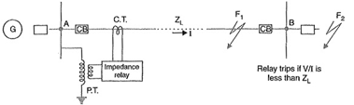

Fig. illustrates the basic principle of operation of an impedance relay. The voltage element of the relay is excited through a potential transformer (P.T.) from the line to be protected. The current element of the relay is excited from a current transformer (C.T.) in series with the line. The portion AB of the line is the protected zone.. Under normal operating conditions, the impedance of the protected zone is ZL. The relay is so designed that it closes its contacts whenever impedance of the protected section falls below the pre-determined value i.e.ZL in this case.

Now suppose a fault occurs at point F1 in the protected zone. The impedance Z (=*V/I) between the point where the relay is installed and the point of fault will be less than ZL and hence the relay operates. Should the [fault](http://www.allaboutcircuits.com/) occur beyond the protected zone (say point F2), the impedance Z will be greater than ZL and the relay does not operate.

**Operating Characteristic of an Impedance Relay:**

The voltage and the current operating elements are the two important component of the impedance relay. The current operating element generates the deflecting torque while the voltage storage element generates the restoring torque. The torque equation of the relay is shown in the figure below

[operating-characteristic-of-an-impedance-relay-equation-1](https://circuitglobe.com/wp-content/uploads/2016/07/operating-characteristic-of-an-impedance-relay-equation-11-compressor.jpg)

The -K3 is the spring effect of the relay. The V and I are the value of the voltage and current. When the relay is in normal operating condition, then the net torque of the relay becomes zero.

[impedance-type-distance-relay-equation-2-](https://circuitglobe.com/wp-content/uploads/2016/07/impedance-type-distance-relay-equation-2-compressor.jpg)

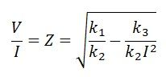

If the spring control effect becomes neglected, the equation becomes

[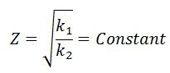](https://circuitglobe.com/wp-content/uploads/2016/07/impedance-type-distance-relay-equation-4-compressor.jpg)

The operating characteristic concerning the voltage and current is shown in the figure below. The dashed line in the image represents the operating condition at the constant line impedance.

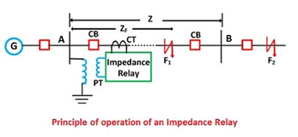

The operating characteristic of the impedance relay is shown in the figure below. The positive torque region of the impedance relay is above the operating characteristic line. In positive torque region, the impedance of the line is more than the impedance of the faulty section. Similarly, in negative region, the impedance of the faulty section is more than the line impedance

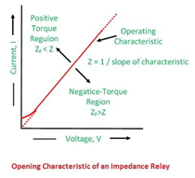

The impedance of the line is represented by the radius of the circle. The phase angle between the X and R axis represents the position of the vector. If the impedance of the line is less than the radius of the circle, then it shows the positive torque region. If the impedance is greater than the negative region, then it represents the negative torque region.

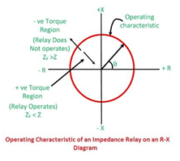

This type of relay is called the high-speed relay.

**Types of Distance Relays or Impedance Relays:**

A distance or impedance relay is essentially an ohmmeter and operates whenever the impedance of the protected zone falls below a pre-determined value. There are two types of distance relays in use for the protection of power supply, namely ;

1. **Definite-Distance relay** which operates instantaneously for fault up to a pre-determined distance from the relay.
2. **Time-Distance relay** in which the time of operation is proportional to the distance of fault from the relay point. A fault nearer to the relay will operate it earlier than a fault farther away from the relay.

It may be added here that the distance relays are produced by modifying either of two types of basic relays; the balance beam or the induction disc.

**Definite Distance Type Impedance Relay:**

Fig. shows the schematic arrangement of a Definite Distance Type Impedance Relay. It consists of a pivoted beam F and two electromagnets energized respectively by a current and voltage transformer in the protected circuit. The armatures of the two electromagnets are mechanically coupled to the beam on the opposite sides of the fulcrum. The beam is provided with a bridging piece for the trip contacts. The relay is so designed that the torques produced by the two electromagnets are in the opposite direction.

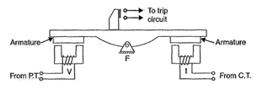

**Operation:** Under normal operating conditions of this Definite Distance Type Impedance Relay, the pull due to the voltage element is greater than that of the current element. Therefore, the relay contacts remain open. However, when a fault occurs in the protected zone, the applied voltage to the relay decreases whereas the current increases. The ratio of voltage to current (i.e. impedance) falls below the pre-determined value. Therefore, the pull of the current element will exceed that due to the voltage element and this causes the beam to tilt in a direction to close the trip contacts.

The pull of the current element is proportional to I2 and that of voltage element to V2. Consequently, the relay will operate when

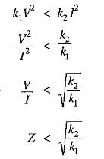

The value of the constants k1 and k2 depends upon the ampere-turns of the two electromagnets. By providing tappings on the coils, the setting value of the relay can be changed

### ****Time Distance Impedance Relay:****

A time-distance impedance relay is one which automatically adjusts its operating time according to the distance of the relay from the fault point i.e.

Definite Distance Type Impedance Relay

**Construction:** Fig. shows the schematic arrangement of a typical induction type time-distance impedance relay. It consists of a current driven induction element similar to the double-winding type induction overcurrent relay. The spindle carrying the disc of this element is connected by means of a spiral spring coupling to a second spindle which carries the bridging piece of the relay trip contacts. The bridge is normally held in the open position by an armature held against the pole face of an electromagnet excited by the voltage of the circuit to be protected.

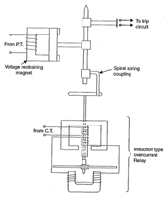

**Operation:** Under normal load conditions, the pull of the armature is more than that of the induction element and hence the trip circuit contacts remain open. However, on the occurrence of a short-circuit, the disc of the induction current element starts to rotate at a speed depending upon the operating current. As the rotation of the disc proceeds, the spiral spring coupling is wound up till the tension of the spring is sufficient to pull the armature away from the pole face of the voltage-excited magnet. Immediately this occurs, the spindle carrying the armature and bridging piece moves rapidly in response to the tension of the spring and trip contacts are closed. This opens the circuit breaker to isolate the faulty section.

The speed of rotation of the disc is approximately proportional to the operating current, neglecting the effect of control spring. Also the time of operation of the relay is directly proportional to the pull of the voltage-excited magnet and hence to the line voltage V at the point where the relay is connected. Therefore, the time of operation of [relay](http://www.allaboutcircuits.com/) would vary as V/I i.e. as Z or distance.

**Differential Relays:**

Most of the relays discussed so far relied on excess of current for their operation. Such relays are less sensitive because they cannot make correct distinction between heavy load conditions and minor fault conditions. In order to overcome this difficulty, differential relays are used.

**A differential relays is one that operates when the phasor difference of two or more similar electrical quantities exceeds a pre-determined value.**

Thus a current differential relays is one that compares the current entering a section of the system with the current leaving the section. Under normal operating conditions, the two currents are equal but as soon as a fault occurs, this condition no longer applies. The difference between the incoming and outgoing currents is arranged to flow through the operating coil of the relay. If this differential current is equal to or greater than the pickup value, the relay will operate and open the circuit breaker to isolate the faulty section.

It may be noted that almost any type of relay when connected in a particular way can be made to operate as a differential relay. In other words, it is not so much the relay construction as the way the relay is connected in a circuit that makes it a differential relays. There are two fundamental systems of differential or balanced protection viz.

### ****Current balance protection****

### ****Voltage balance.protection****

### ****Current Differential Relays:****

Fig. shows an arrangement of an overcurrent relay connected to operate as a differential relay. A pair of identical current transformers are fitted on either end of the section to be protected (alternator winding in this case). The secondaries of CT’s are connected in series in such a way that they carry the induced currents in the same direction. The operating coil of the overcurrent relay is connected across the CT secondary circuit. This differential relays compares the current at the two ends of the alternator winding.

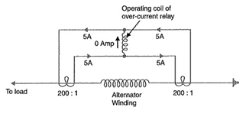

Under normal operating conditions, suppose the alternator winding carries a normal current of 1000 A. Then the currents in the two secondaries of CT’s are equal . These currents will merely circulate between the two CT’s and no current will flow through the differential relays. Therefore, the relay remains inoperative. If a ground fault occurs on the alternator winding as shown in Fig.(i), the two secondary currents will not be equal and the current flows through the operating coil of the relay, causing the relay to operate. The amount of current flow through the relay will depend upon the way the fault is being fed.

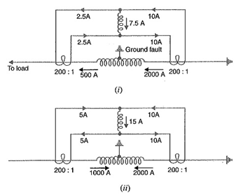

**(i) If some current (500 A in this case) flows out of one side while a larger current (2000 A) enters the other side as shown in Fig. (i), then the difference of the CT secondary currents i.e. 10 – 2.5 = 7.5 A will flow through the relay.**

**(ii) If current flows to the fault from both sides as shown in Fig. (ii), then sum of CT secondary currents i.e. 10 + 5 = 15 A will flow through the relay.**

**Disadvantages**

* **The impedance of the pilot cables generally causes a slight difference between the currents at the two ends of the section to be protected. If the relay is very sensitive, then the small differential current flowing through the relay may cause it to operate even under no fault**
* **Pilot cable capacitance causes incorrect operation of the relay when a large through-current**
* **Accurate matching of current transformers cannot be achieved due to pilot circuit impedance.**

The above disadvantages are overcome to a great extent in biased beam relay.

**Biased Beam Relay:** The biased beam relay (also called **Percentage Differential Relay**) is designed to respond to the differential current in terms of its fractional relation to the current flowing through the protected section. Fig. shows the schematic arrangement of a biased beam relay. It is essentially an overcurrent balanced beam relay type with an additional restraining coil. The restraining coil produces a bias force in the opposite direction to the operating force.

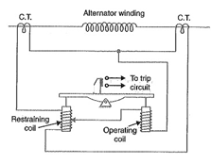

Under normal and through load conditions, the bias force due to restraining coil is greater than the operating force. Therefore, the relay remains inoperative. When an internal fault occurs, the operating force exceeds the bias force. Consequently, the trip contacts are closed to open the circuit breaker. The bias force can be adjusted by varying the number of turns on the restraining coil.

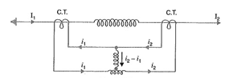

The equivalent circuit of a biased beam relay is shown in Fig. The differential current in the operating coil is proportional to i2 — i1 and the equivalent current in the restraining coil is proportional to (i1 + i2)/2 since the operating coil is connected to the mid-point of the restraining coil. It is clear that greater the current flowing through the restraining coil, the higher the value of current required in the operating winding to trip the relay. Thus under a heavy load, a greater differential current through the relay operating coil is required for operation than under light load conditions. This relay is called **Percentage Relay** because the operating current required to trip can be expressed as a percentage of load current.

### ****Voltage Balance Differential Relays:****

Fig. shows the arrangement of voltage balance protection. In this scheme of protection, two similar current transformers are connected at either end of the element to be protected (e.g. an alternator winding) by means of pilot wires. The secondaries of current transformers are connected in series with a relay in such way that under normal conditions,their induced e.m.f.s’  are in opposition.

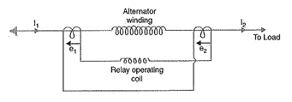

Under healthy conditions, equal currents II = I2) flow in both primary windings. Therefore, the secondary voltages of the two transformers are balanced against each other and no current will flow through the relay operating [coil](http://www.allaboutcircuits.com/). When a fault occurs in the protected zone, the currents in the two primaries will differ from one another (i.e. I1 ≠ I2) and their secondary voltages will no longer be in balance. This voltage difference will cause a current to flow through the operating coil of the relay which closes the trip circuit.

**Disadvantages**

The voltage balance system suffers from the following drawbacks:

* **A multi-gap transformer constriction is required to achieve the accurate balance between current transformer pairs.**
* **The system is suitable for protection of cables of relatively short lengths due to the capacitance of pilot wires. On long, cables, the charging current may be sufficient to operate the relay even if a perfect balance of current transformers is attained.**

The above disadvantages have been overcome in Translay (modified) balanced voltage system.

# Negative Sequence Relay:

**Definition**: **A relay which protects the electrical system from negative sequence component is called a negative sequence relay or unbalance phase relay.** The negative sequence relay protects the generator and motor from the unbalanced load which mainly occurs because of the phase-to-phase faults.

The negative sequence relay has a filter circuit which operates only for the negative sequence components. The relay always has a low current setting because the small magnitude overcurrent can cause dangerous situations. The negative sequence relay has earthing which protects them from phase to earth fault but not from phase to phase fault. The phase to phase fault mainly occurs because of the negative sequence components.

The construction of the negative sequence relay is shown in the figure below. The Z1, Z2, Z3, and Z4 are the four impedance of the circuit which is connected in the form of the bridge. The impedance is energized by the current transformers. The relay operating coil is connected to the midpoint of the circuit as shown in the figure below.

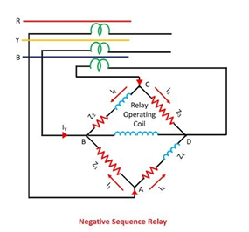

The Z1 and Z3 are purely resistive and the Z2 and Z4 are both resistive and inductive in nature. The impedance Z2 and Z4 are adjusted in such a manner that the current flowing through them is always lagging by an angle of 60º than those current which is flowing through Z1 and Z3. The current flowing through the junction A is split into two parts i.e. I1 and I4. The I4 lagging by an angle of 60º regards I1.

[negative-sequential-relay-equation-1](https://circuitglobe.com/wp-content/uploads/2016/07/negative-sequential-relay-equation-1-compressor-1.png)[negative-sequence-equation-2](https://circuitglobe.com/wp-content/uploads/2016/07/negative-sequence-equation-2-compressor.jpg)

Similarly, current from phase B split at junction C into two equal components I3 and I2, I2 lagging behind I3 by 60º.

[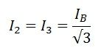](https://circuitglobe.com/wp-content/uploads/2016/07/negative-sequence-relay-equation-3-compressor.jpg)

The current I4 lags by an angle of 30º to the I1. Similarly, I2 lags by an angle of 30º concerning IB and I3 leads IB by 30º. The current passing through the junction B is equal to the sum of I1, I2, and IY.

[negative-sequence-relay-4](https://circuitglobe.com/wp-content/uploads/2016/07/negative-sequence-relay-4-compressor.jpg)[negative-sequence-equation-5](https://circuitglobe.com/wp-content/uploads/2016/07/negative-sequence-equation-5-compressor.jpg)

**The flow of Positive Sequence Current** – The phasor diagram of positive sequence components is shown in the figure below. When the load is in balanced conditions, then there is no negative sequence current. The current flows through the relay is given by the equation

[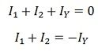](https://circuitglobe.com/wp-content/uploads/2016/07/negative-sequence-relay-equation-6-compressor.jpg)

So the relay remains operative for a balanced system.

**The flow of Negative Sequence Current** – The figure above shows that the current I1 and I2 are equal. Thus, they cancel each other. The current IY flows through the operating coils of the relay. The current setting value of the relay is kept less than the normal full load rating current because the small overload current can cause the serious conditions.

**The flow of Zero Sequence Current**  – The current I1 and I2 are displaced from each other by an angle of 60º. The resultant of the current is in phase with the current IY. The total current twice of the zero sequence current flows through the operating coil of the relay. The relay can be inoperative by connecting the CTs in the delta. In delta connection no zero sequence current flows through the relay.

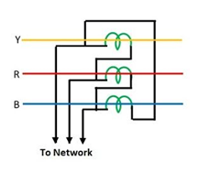

### Induction type Negative Sequence Relay

The construction of induction type negative phase sequence relay is similar as that of an induction type overcurrent relay. This relay consists of a metallic disc usually made up of an aluminium coil, and this is rotating between two electromagnets the upper and the lower electromagnets.

The upper electromagnet has two winding, the primary winding of the upper electromagnet is connected to the secondary of the CT connected in the line to be protected. The secondary winding of the upper electromagnet is connected in series with the windings on the lower electromagnet

The primary winding of the relay has three terminals because of the centre tapping. The phase R energized the upper half of the relay by the help of CTs and auxiliary transformer while the lower half is energized by the phase Y. The auxiliary transformer is so adjusted that their output is lagged by an angle of 120º instead of 180º.

**The operation for Positive Sequence Currents** – The current IR and IY flow through the primary windings of the relay. The current flows in the opposite direction. The current I’R and I’Yare equal in magnitude. The balanced current kept the relay inoperative.

**The operation for Negative Sequence currents**– The negative sequence current I flow in the primary winding of the relay because of the fault current.

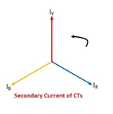

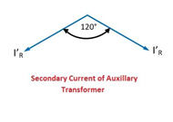

The relay starts operating when the magnitude of the fault current is more than that of the relay setting.

**Under frequency relays**

The frequency relays are normally used in generator protection and for load-frequency control. The frequency of induced e.m.f. of synchronous generator is maintained constant by constant speed. ... In order to avoid damage to the generator under the above two conditions, frequency relays are used.

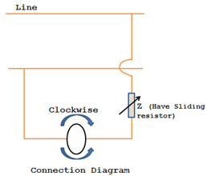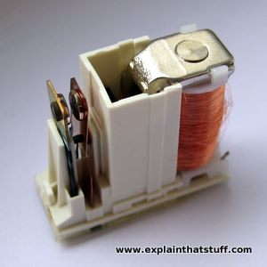

Frequency based relays can either be under frequency relay or over frequency relay.

The frequency relays are normally used in generator protection and for load-frequency control.

The frequency of induced e.m.f. of synchronous generator is maintained constant by constant speed. Over speeding of the generator occurs due to loss of load and under speeding occurs due to increase in load. In both the cases, the frequency varies from normal value. In order to avoid damage to the generator under the above two conditions, frequency relays are used. Under frequency relay trips the feeder on load at set value of frequency, so as to give relief to the generator, thereby saving the unit. Under frequency relay thus aids load shedding programme to save the grid.

**STATIC RELAYS:**

The relay which does not contain any moving parts is known as the static relay. In such type of relays, the output is obtained by the static components like magnetic and electronic circuit etc. The relay which consists static and electromagnetic relay is also called static relay because the static units obtain the response and the electromagnetic relay is only used for switching operation.

The component of the static relay is shown in the figure below. The input of the current transformer is connected to the transmission line, and their output is given to the rectifier. The rectifier was rectifying the input signal and pass it to the relaying measuring unit.

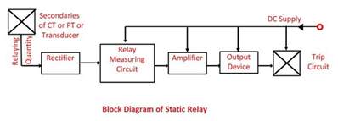

The rectifying measuring unit has the comparators, level detector and the logic circuit. The output signal from relaying unit obtains only when the signal reaches the threshold value. The output of the relaying measuring unit acts as an input to the amplifier.

The amplifier amplifies the signal and gives the output to the output devices. The output device activates the trip coil only when the relay operates. The output is obtained from the output devices only when the measurand has the well-defined value. The output device is activated and gives the tripping command to the trip circuit.

The static relay only gives the response to the electrical signal. The other physical quantities like heat temperature etc. is first converted into the analogue and digital electrical signal and then act as an input for the relay.

### Advantages of Static Relay:

The following are the benefits of static relays.

1. The static relay consumes very less power because of which the burden on the measuring instruments decreases and their accuracy increases.
2. The static relay gives the quick response, long life, high reliability and accuracy and it is shockproof.
3. The reset time of the relay is very less.
4. It does not have any thermal storage problems.
5. The relay amplifies the input signal which increases their sensitivity.
6. The chance of unwanted tripping is less in this relay.
7. The static relay can easily operate in earthquake-prone areas because they have high resistance to shock.

### Limitations of Static Relay:

* The components used by the static relay are very sensitive to the electrostatic discharges. The electrostatic discharges mean sudden flows of electrons between the charged objects. Thus special maintenance is provided to the components so that it does not affect by the electrostatic discharges.
* The relay is easily affected by the high voltage surges. Thus, precaution should be taken for avoiding the damages through voltage spikes.
* The working of the relay depends on the electrical components.
* The relay has less overloading capacity.
* The static relay is more costly as compared to the electromagnetic relay.
* The construction of the relay is easily affected by the surrounding interference.

# Classification of Static Relays:

Static relays are classified according to the type of the measuring unit or comparator as follows: 1. Electronic Relays 2. Transductor (Magnetic Amplifier Relays) 3. Rectifier Bridge Relays 4. Transistor Relays 5. Hall Effect Relays 6. Gauss Effect Relays.

#### 1. Electronic Relays:

These were the first to be developed in the series of static relays. Fitzgerald presented a carrier current pilot relaying scheme for the protection of transmission lines in 1928. Subsequently a series of electronic circuits for most of the common types of protective gear relays were developed. The components used were electronic valves for measuring unit.

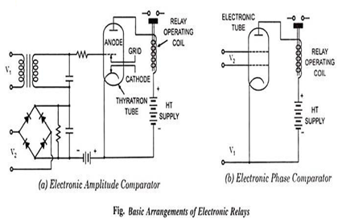

Two basic arrangements are shown in Fig. One uses an amplitude comparator [Fig. (a)] and the other makes use of a phase comparator [Fig. (b)]. In the former arrangement two ac quantities under comparison are rectified and applied in opposition in the control grid circuit of an electronic tube and the operation occurs when one quantity exceeds the other by an amount depending on the bias. In the latter arrangement one ac quantity is connected to the control grid and the other to the screen grid of the electronic tube. Operation occurs when the two ac quantities under comparison are in phase.

Inspite of the advantages of fast operation, low maintenance, low burden on CTs and PTs, absence of mechanical inertia and bouncing contacts, they suffered inherently from the requirements of ht supply, short life, large power consumption, It supply for the heater elements. These relays could not meet practical requirements and hence never reached the commercial stages.

**2.Transductor Relay (Magnetic Amplifier Relay):**

Transductor Relay – Since relays now have to perform much more complicated functions, many types tend to become very complex mechanically, and hence costly, to make and difficult to test and to maintain. The transductor controlling a simple slave relay, makes it possible to reduce a complex electromechanical device which operates in accordance with the interaction of fluxes and currents in a fully predictable way.

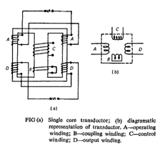

A transductor comprises essentially a magnetic core on which there are two groups of windings, usually known respectively as the operating wind­ings and control windings. Each group may comprise only one winding but if there is more than one winding in a group all those windings are magnetically linked. On the other hand the windings of the different groups are not magnetically linked. The operating windings are energized with a.c. and control windings are energized with d.c.

A transductor operates so as to present a variable impedance to currents flowing in the operating windings the magnitude of this impedance being varied by the current in the control winding. Figure shows a single core transductor.

If used as an amplitude comparator it is limited in its sensitivity by the sensitivity of the slave relay in its output circuit; if used as a phase comparator to obtain greater sensitivity it is dependent upon an external a c. supply which is sometimes difficult to arrange.

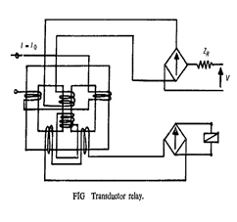

Fig.shows a transductor relay where the restraining voltage is applied to the control winding through an impedance ZR and a rectifier. The restraining current thus obtained is rectified and partially smoothed by the short-circuit effect of the rectifier on control winding and also due to the short circuited coupling winding. The effect of this is to drive both the limbs on which the operating winding is wound into saturation.

Now the operating winding is wound in such a way that the operating ampere-turns oppose the restraining ampere-turns in one limb and reinforce them in the other. Neglecting the finiteness of permeability and assuming equality of restraining and operating turns, the operating current would drive out of saturation, the limb in which operating current is against the restraining ampere-turns, when the peak value of the operating current exceed the magnitude of [restraining current](https://www.ias.ac.in/). When this happens a voltage is induced in the output winding and the relay is energized. The same operation is repeated on the other limb during the next half cycle.

The slave relay current is very low until the above mentioned condition exists. Then it suddenly increases and becomes very large for a small value of operating current. For this reason a heavy duty of telephone type of relay is used with large setting. Due to smoothing and rectifying a signal, a delay is introduced because of the time constant of the smoothing circuit and hence the operating speed is slow.

Transductor Relay are mechanically very simple and although some of them may appear to be a little complicated electrically, this does not affect their reliability adversely, since their operation is mainly dependent on static components whose characteristics are easily predetermined and checked. As a result they are easier to construct and test than electromechanical relays and their maintenance is practically negligible.

#### 3. Rectifier Bridge Relays:

Such relays became popular because of development of semiconductor diodes. This relay consists of two rectifier bridges and a moving coil or polarized moving iron relay. The most common are relay comparators based on rectifier bridges, which can be arranged as either amplitude or phase comparators.

#### 4. Transistor Relays:

Transistor relays are the most widely used static relays. Transistor which acts like a triode can overcome most of the limitations posed by the electronic valves and thus has made possible to develop the electronic relays more commonly known as static relays.

The fact that a transistor can be employed both as an amplifying device and a switching device makes it suitable for achieving any functional characteristic. The transistor circuits cannot only perform the essential functions of a relay (such as comparison of inputs, summation and integrating them) but they also provide necessary flexibility to suit the various relay requirements.

Two basic arrangements of relays based on transistor comparators are shown in Fig.

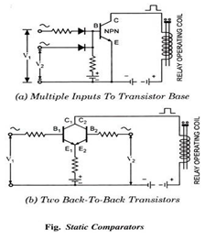

In either of the circuits shown in Fig. (a) and (b) current of constant magnitude flows in the collector circuit only when the input ac quantities are simultaneously positive; a relay in the collector circuit will pick up when the overlap angle exceeds a certain value, i.e., when the mean dc level in the collector circuit exceeds the relay pick-up as a consequence of phase coincidence.

#### 5. Hall Effect Relays:

When a conductor is kept perpendicular to the magnetic field and a direct current is passed through it, it results in an electric field perpendicular to the directions of both the magnetic field and current with a magnitude proportional to the product of the magnetic field strength and current. The voltage so developed is very small and it is difficult to detect it. But in some semiconductors such as indium arsenide, indium antimonite, indium phosphate, germanium etc., this voltage is enough for measurement with a sensitive moving coil instrument. This phenomenon is called the Hall Effect.

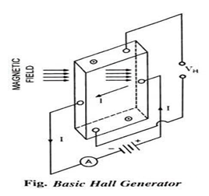

Figure illustrates the basic Hall generator where the Hall crystal in the form of a slab is connected to a battery so that a current I flows through the slab in the manner shown in the figure and the magnetic field is applied so that it is perpendicular to the slab of the Hall crystal. A potential difference VH, called the Hall voltage, is developed between the top and bottom of the slab. The magnitude of this voltage is proportional to the product of strength of the magnetic field and current.

Let ɸ = ɸmax sin ωt

and i = Imax sin (ωt – α)

then Hall voltage VH is given as –

VHα ɸi α ɸmaxImaxsin ωt sin (ωt – α)

= KH ɸmaxImax [cos α – cos (2ωt – α)] … (1)

In the above expression the first term on the right hand side is a dc voltage proportional to the vectorial product of the two inputs—flux and current—the second term is an ac voltage of double frequency. The double frequency term can be eliminated by cross-connecting two Hall generators, as illustrated in Fig. where two input signals are the sinusoidal ac currents I1 and I2.

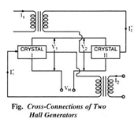

If currents I1 and I2 are given as –

I1= I1max sin ωt and I2 = I2max sin (ωt – α) …(2)

Flux through crystals I and II will be ɸ1 α I1 and ɸ2 α I2

and current through the crystals will be I’1 [α (dI2/dt)] and I2 [α (dI1/dt)] …(3)

Two crystals I and II are connected in such a way that their output voltages are in opposition. So the output voltage will be –

VH α (V1 – V2) α {[I1(dI2/dt)] – [I2 (dI1/dt)]}

α I1max sin ωt x I2max ω cos (ωt – α) – I2max sin (ωt – α). ω I1max cos ωt

or VH α I1max I2max sin [ωt –(ωt – α)] α I1max I2max sin α …(4)

The device thus acts as a pure phase comparator. A telephone type relay can be directly operated from the Hall voltage. Hall device is much simpler in construction and does not require auxiliary dc supply while the transistorized circuits require about 10V dc supply.

Because of the high cost of Hall element, low output and large temperature error, this comparator is normally not used.

#### 6. Gauss Effect Relays:

The resistivity of some metals and semiconductors at low temperature changes when exposed to the magnetic field. This phenomenon is called the magneto resistivity or Gauss effect. This effect depends upon the ratio of depth to width and increases with the increase in this ratio. In some metals, this effect is noticeable at room temperature, as in case of bismuth. Magneto resistors are sensitive to the magnetic field strength and not to the rate of variation. Indium antimonite and indium arsenide are more sensitive in comparison to bismuth or mumetal.

If one ac voltage V1 develops a magnetic field through the crystal in the form of disc having large diameter and another ac voltage V2 sends a current radially through the disc, then the current will be proportional to V1V2cos θ where θ is the angle between the two voltages V1 and V2 i.e., current is maximum when the two voltages are in phase and zero when they are in quadrature. Such a relay is considered better than Hall Effect relay because of simpler construction and circuitry. Polarizing current is not required and output is relatively higher. But its use in static relays is limited because of high cost of crystal.

**Static Amplitude Comparator:**

If the two input signals are S1 and S2 the amplitude comparator gives positive (yes) output only if S2/S1 ≤ K (Fig.), S1 is the operating quantity and S2 is the restraining quantity. Ideally, the comparison of the two input signals is independent of their level and their phase relationship. The function is represented by a circle in the complex plane, with its centre at the origin: this defines the boundary of the marginal operation. Static Amplitude Comparator may be of the following types:

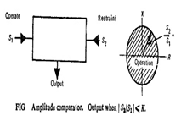

1. **Inte­grating comparators,**
2. **Instantaneous comparators, and**
3. **Sampling comparators.**

**Integrating Comparators:**

It is possible to arrange rectifier bridge networks as amplitude comparators. Rectifier bridge comparator can either be of circulating current type or opposed voltage type.

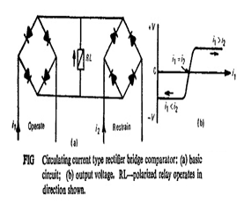

Basic circuit for the circulating current type of Static Amplitude Comparator is shown in Fig. The polarized relay operates when S1>S2, where S1=K1i1 and S2=K2i2. This arrangement provides a sensitive relay whose voltage may be ideally represented by Fig. The relay voltage will never exceed twice the forward voltage drop of the rectifiers, and typically will be of the order of 1 volt.

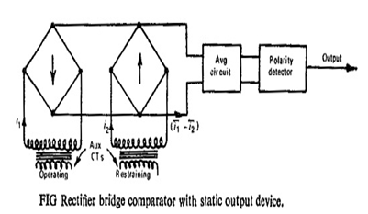

Instead of the polarized relay a static integrator can be used consisting of an averaging circuit and the polarity detector circuit as shown in Fig. The two currents i1 and i2 are rectified and their difference (i1 – i2) is averaged. The output is obtained only if the averaged value is positive.

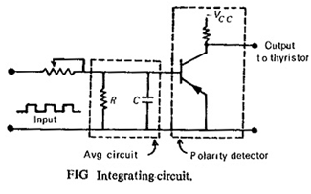

An integrator circuit is shown in Fig. The tripping occurs when the capacitor voltage reaches the setting value of the level detector and triggers a thyristor.

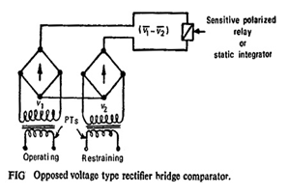

The opposed voltage type comparator shown in Fig. works with voltage input signals derived from PTs. The operation in this case depends on the average of the difference of the rectified voltages (v1-v2). In this case the limiting action is the wrong way, as the rectifiers have higher resistance at lower voltages. Also the rectifiers are not protected at higher currents

**Instantaneous Comparators:**

Instantaneous or direct amplitude comparators can be of two types: **averaging type** and **phase splitting type**.

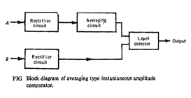

In the averaging type instantaneous amplitude comparator the restrain­ing signal is rectified and smoothed completely in order to provide a level of restraint. This is then compared with the peak value of the operating signal, which may or may not be rectified, but is not smoothed. The tripping signal is provided if the operating signal exceeds the level of restraint. The block schematic diagram is shown in Fig. The wave shapes are shown in Fig.

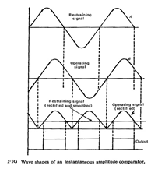

Since the above method involves smoothing the operation is slow. A faster method is phase splitting before rectification as shown in Fig.

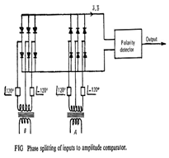

Here the input is split into six components 60° apart, so that, it is smoothed within 5%. The averaging circuit can be eliminated. The operating time here is determined by the time constant of the slowest arm of the phase-splitting circuit and by the speed of the output device.

**Sampling Comparators:**

Sometimes it is convenient to get the required characteristics by comparing the magnitude of one input signal at a certain point on its wave against the rectified and smoothed value of the second signal.

**Phase comparators:**

Phase comparison technique is the most widely used technique for all practical directional, distance, differential and carrier relays.

In a phase comparator, the operation of the relay takes place when the phase relation between two inputs S1 and S2 var­ies within certain specified limits. Both inputs must exist for an output to occur; ideally, operation is independent of their amplitudes, and depends only on their phase relationship. The function, as defined by the boundary of marginal operation, is represented by two straight lines from the origin of the complex plane.

Mathematically, the condition of operation is given as –

– α1 ≤ θ ≤ α2

Where, θ is the angle by which S1 lags behind S2. If α1 = α2 = 90° the comparator is called the cosine comparator and if α1 = 0 and α2 = 180°, it is called the sine comparator.

**Static phase comparators are of two types viz.:**

1. Coincidence type phase comparator and

2. Vector product phase comparator.

In these comparators the output is proportional to vector product of the ac input signals. the hall effect phase comparator and magneto-resistivity phase comparators come under this category of phase comparators.

**1. Coincidence Type Phase Comparators:**

The basic concept of phase comparison is simpler in that it is possible to deal with signals of equal strength whose coincidence or non-coincidence is readily measurable. Let us consider two sinusoidal signals S1 and S2. Their period of coincidence depends upon their phase difference. Fig illustrates the coincidence of signals S1 and S2 for different phase angles.

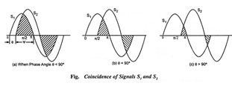

It can be seen that the period of coincidence of two sinusoidal signals S1 and S2 is = (180° – θ) where 0 is the phase angle between S1 and S2. It means if the operation is desired for a phase angle θ less than 90°, then coincidence period should be greater than 90°. Thus, the criterions for operation becomes – 90° ≤ θ ≤ 90°.

By measuring the period of coincidence, it is possible to design the circuit to give an output a YES or a NO depending upon the phase relation of the input signals.

**Different techniques can be used to measure the period of coincidence, some of them are given below:**

**i. Spikes and Block Coincidence Techniques in Phase Comparator:**

In such a comparator, one of the inputs is converted to square wave and the other into a pulse of short duration at the instant of its zero crossing, peak value or at any angle (preferably at the instant of its peak value). The squared and spike signals are fed through an AND gate. Figure 3.18 shows the schematic block diagram and waveforms. If these two signals coincide at any time, the output then only would be available from the AND gate.

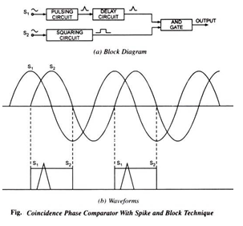

**The output obtainable depends on the instant of spiking and is as follows for different phase difference ranges:**

(i) With spike derived at peak value, output is available for – 90° ≤ θ ≤ 90°

(ii) With spike derived at zero value, output is available for 0 ≤ θ ≤ 180°.

(iii)With spike derived at any other instant a, output is available for 0 ≤ θ ≤ 180° – α

Squaring of one input signal is obtained by first limiting it and then amplifying it so that the rectangular block is in phase with the original sine wave. The spike is produced by a peaking transformer or by squaring the wave through the diodes and feeding it through a transformer. The spike is obtained at zero value of the sine wave in each case. This is shifted as per requirement through the delay circuit. A comparison is made after every half cycle. The main drawback of such a comparator is that in case of spurious spikes due to any switching or external interference, the relay may operate which is not desirable. Shielding of the circuit against electric and magnetic fields is, therefore, essential.

**ii. Phase Comparator with Phase Splitting Technique:**

Figure illustrates this method in which both the input signals S1 and S2 are split into two components S1∠-45°, S1 ∠45°, S2 ∠-45°, and S2∠45° with respect to the original signal. The four components are then fed into an AND gate which gives an output when all the four inputs are simultaneously positive at any time in the cycle. The coincidence of all the four signals is possible when the phase angle θ satisfies the condition -90° ≤ θ ≤ 90°.

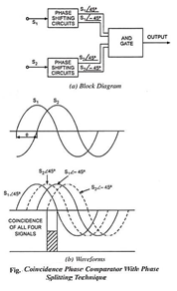

### ****Duality Between Amplitude and Phase Comparators:****

### In amplitude comparison technique, the comparator produces an output whose amplitude is proportional to the amplitude difference of the input quantities; while in phase comparison technique, the comparator compares the phase angles of the input quantities and produces pulses whose width is proportional to the phase difference of the input quantities

The Comparator Equation in Power System Protection of a circle on complex planes and indicate that an operating characteristic equation can be obtained either by a phase comparator or by an amplitude comparator through proper selection of the four constants K1 through K4. This further suggests the possibility of a simple relation between the two comparators and it can be proved that an inherent amplitude comparator becomes a phase comparator and vice versa, if the input quantities are changed to the sum and difference of the original two input quantities.

Consider the operation of an amplitude comparator with input signals A and B. It operates, say, when

[https://www.eeeguide.com/wp-content/uploads/2019/05/Comparator-Equation-in-Power-System-Protection-17.jpg](https://www.eeeguide.com/wp-content/uploads/2019/05/Comparator-Equation-in-Power-System-Protection-17.jpg)

If the inputs are changed to (A + B) and (A — B) so that it operates when

[https://www.eeeguide.com/wp-content/uploads/2019/05/Comparator-Equation-in-Power-System-Protection-18.jpg](https://www.eeeguide.com/wp-content/uploads/2019/05/Comparator-Equation-in-Power-System-Protection-18.jpg)

It has now become an inherent phase comparator as shown in Fig. vector diagram, i.e. if the inputs are changed to (A + B) and (A—B) the original amplitude comparator would compare phases of A and B.

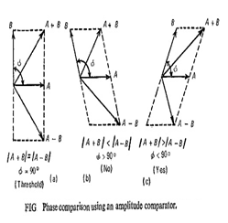

Similarly, a phase comparator working with inputs A and B, operates when A and B have same directional sense. If now the inputs are changed to (A + B) and (A—B) it would operate when (A + B) and (A—B) have the same directional sense, i.e. |A| > |B| as shown in Fig. (4.4). Such comparators are known as **converted comparators**.

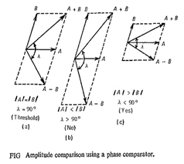

Though a given relay characteristic can be obtained using either of the two comparators, consideration of the constants calculated for required characteristics would indicate which type of comparator is preferable. In general an inherent comparator is better than the converted type, because if one quantity is very large compared with the other, a small error in the large quantity may cause an incorrect comparison when their sum and difference are supplied as inputs to the [relay](https://www.bosch-mobility-solutions.com/).